R. Reports Menu: 5. Detail Transactions

Table of Contents
Detail Transactions 3
The “Transaction Options” tab 3
The “Output” tab 5
The “Accounts” tab 6
The “More Accounts” tab 8

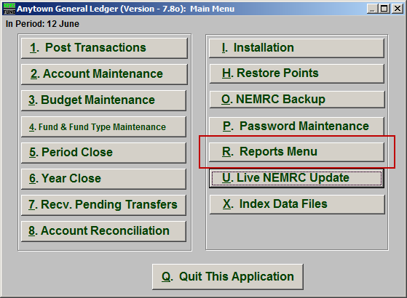
Click on “R. Reports Menu” from the Main Menu and the following window will appear:

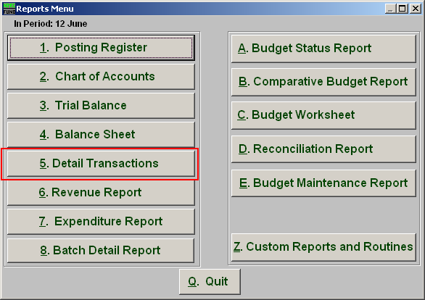
Click on “5. Detail Transactions” from the Reports Menu and the following window will appear:

Detail Transactions

The “Transaction Options” tab

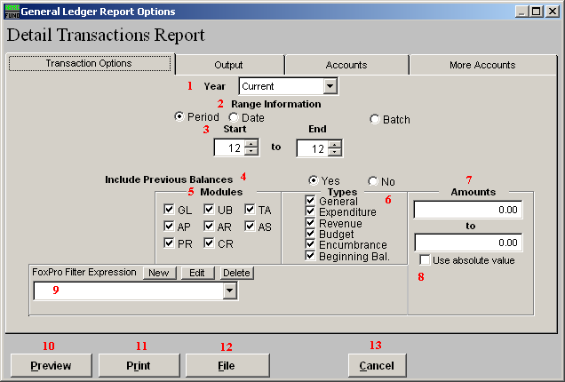

- Year: Select from either Current or Last Year to have the report be for.

- Range Information: Select Period, Date OR Batch.

- Start to End: Depending what you selected for Range, enter the corresponding number OR date.

- Include Previous Balances: Select “Yes” if you would like previous balance to appear on the report.

- Modules: Select the Modules you would like the report to include.

- Types: Select the Types of transactions you would like the report to include.

- Amounts: The option is available to restrict the report to posting amounts in a value range. This is helpful when trying to locate a specific amount for a transaction.

- Use absolute value: Check this box if you are unsure about the transaction amounts posting as a credit or debit values to ensure reporting both occurrences.

- FoxPro Filter Expression: A conditional reporting expression developed with NEMRC support. This evaluates account information to determine if the account should be included. Contact NEMRC support to learn more about this option.

- Preview: Click this button to preview. Refer to GENERAL PREVIEW for more information.

- Print: Click this button to print. Refer to GENERAL PRINTING for more information.

- File: Click this button to save on this computer. Refer to GENERAL FILE for more information.

- Cancel: Click “Cancel” to cancel and return to the previous screen.

The “Output” tab

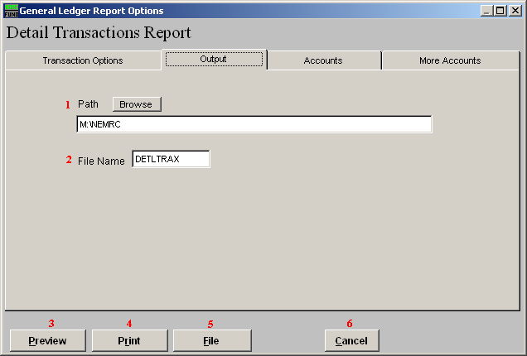

- Path: Type in the location of the folder you wish to save this report in when you export. You may click “Browse” to locate the folder.

- File Name: Type in the name that this report will be saved as

- Preview: Click this button to preview. Refer to GENERAL PREVIEW for more information.

- Print: Click this button to print. Refer to GENERAL PRINTING for more information.

- File: Click this button to save on this computer. Refer to GENERAL FILE for more information.

- Cancel: Click “Cancel” to cancel and return to the previous screen.

The “Accounts” tab

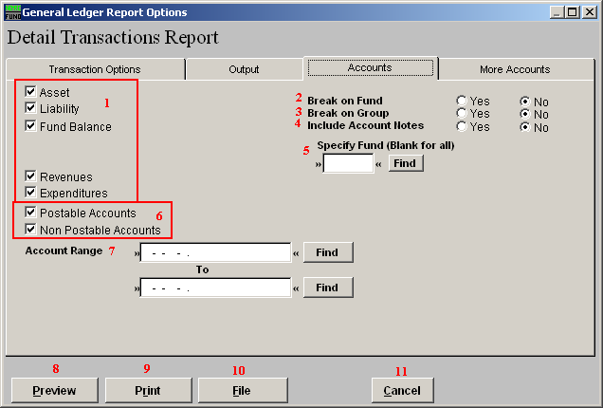

- Account Types: You can select some or all account types to report detail postings for. The types available are dependant on the design of your chart of accounts.

- Break on Fund: Select “Yes” if you want a page break between funds.

- Break on Group: Select “Yes” if you want a page break between the second components of your account structure. This is dependant on the design of your chart of accounts.

- Include Account Notes: Choose “Yes” to have this report include Account Notes that can be entered in Account Maintenance.

- Specify Fund: Type the Fund number you would like the report be for OR leave blank for all.

6. Postable Accounts, Non Postable Accounts: Select the option to include accounts that are presently active (postable) and/or inactive (non-postable). You must select at least one of these two choices.

- Account Range: Enter a starting TO ending account number if you want to restrict the report to a specific range of numbers. You can use the “Find” button to select each account point.

- Preview: Click this button to preview. Refer to GENERAL PREVIEW for more information.

- Print: Click this button to print. Refer to GENERAL PRINTING for more information.

- File: Click this button to save on this computer. Refer to GENERAL FILE for more information.

- Cancel: Click “Cancel” to cancel and return to the previous screen.

The “More Accounts” tab

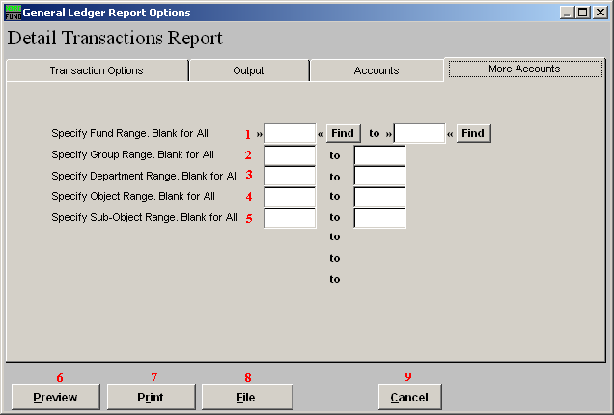
- Specify Fund Range: This option appears for all charts of accounts. Type in a beginning and ending fund number range to further restrict the reporting if desired. Items 2 through 5 will vary according to the design and descriptions for your chart of accounts definitions.

- Specify Group Range: Enter a beginning and ending value range to further restrict the reporting if desired.

- Specify Department Range: Enter a beginning and ending value range to further restrict the reporting if desired.

- Specify Object Range: Enter a beginning and ending value range to further restrict the reporting if desired.

- Specify Sub-Object Range: Enter a beginning and ending value range to further restrict the reporting if desired.

- Preview: Click this button to preview. Refer to GENERAL PREVIEW for more information.

- Print: Click this button to print. Refer to GENERAL PRINTING for more information.

- File: Click this button to save on this computer. Refer to GENERAL FILE for more information.

- Cancel: Click “Cancel” to cancel and return to the previous screen.

